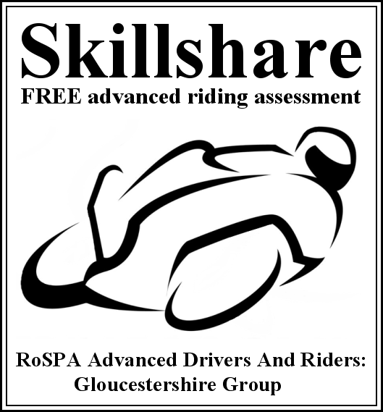


Assessment Ride Report

Date: ________________ Tutor: ______________________________________________

Manoeuvre | Grade |  |  |  |  | Remarks
Moving off
Stopping
Observation
Planning
Machine control
(incl slow speed)
Accelerating
Braking
Gears
Signals
Positioning
Cornering
Overtake / filter
Attitude

